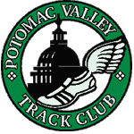Potomac Valley Track Club

Easter Classic 5K run & walk and 10K run
Saturday, April 4, 2026
5K and 10K at 8:30 AM

Bluemont Park, 329 North Manchester Street, Arlington VA
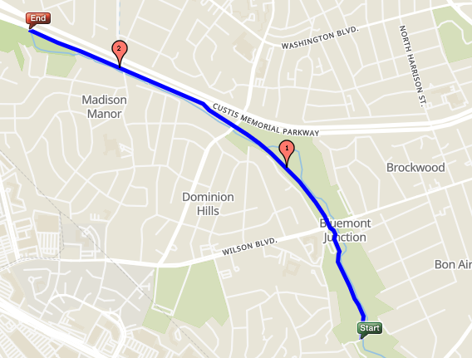● Event: Potomac Valley Track Club Easter Classic
8:30 AM -- 5K run or walk
8:30 AM -- 10K run
- Entry Fee: On-line at www.pvtc.org or by mail
  - by March 21: $10 (PVTC members) $15 (non-members)
  - after March 21 $20 (members) $20 (non-members)
- Directions: From Route 50, turn north at Manchester Street
Continue to the park driveway on the right. Free parking
- Race-day: On-site registration is open
7:15 AM to 8:45 AM – Race-day registration is OK
- Course: Paved park path, one gradual hill
No road crossings, OK for walkers and wheelchairs
- Join us! Join Potomac Valley Track Club for $20
and save $5 on our races including this one– www.pvtc.org/join.php
- Race size: About 100 in each race, 5K and 10K. Only one race per person. Must finish by 10:00 AM
- Awards: Flowers, chocolate bunnies, or Easter baskets for top 3 in 10-year age groups M/F, plus walkers
- Post-race: Refreshments to keep you warm
- Contact: Mike Cannon – pvtcracedirector@gmail.com – 910-261-8446


or scan QR code

Easter Classic bib number
___ ___ ___ ___

Send form and check to
PVTC, 611 South Ivy Street, Arlington VA 22204
or bring this form on race day – or scan the QR code

PVTC ENTRY FORM

Name ________________________________________ Age on race day __ __ M/F __

Address ________________________________________ Birthdate ____ ____, _______

City, State, ZIP ________________________________________ Phone ______________________________

E-mail ____________________________________________________________________________

Event [__] 5K [__] 10K [__] I am a race walker [__] Wheelchair [__] Volunteer
Enclosed is [__] $10 (PVTC members) [__] $15 (non-members) by March 21
Late Entry [__] $20 (PVTC members) [__] $20 (non-members) on or after March 21 on-line closes 4/1
[__] Here is $20 more for membership (then take the member price) – Use this as member form
[__] Here is an additional donation of $ ______ . Total enclosed: $ ______
I know running a race is a potentially hazardous activity. I should not enter and run unless I am medically able and properly trained. I agree to abide by any decision of a race official relevant to my ability to safely complete this event. I assume all risks associated with running in this event, including, but not limited to: CONTRACTION OF ILLNESS INCLUDING COVID19, falls, contact with other participants, effects of the weather, including high heat and/or humidity, and conditions of the course, all such risks being known and appreciated by me. Having read this waiver and knowing these facts, and in consideration of your accepting my entry, I, for myself and anyone entitled to act on my behalf, waive and release all sponsors, including District of Columbia, Arlington County Virginia, their elected and appointed officials and employees, Northern Virginia Regional Park Authority, Potomac Valley Track Club, RRCA, and USATF, their officers, directors, agents, and employees, and all officials of this event from all claims or liabilities of any kind arising out of my participation in this event even though that liability may arise out of negligence or carelessness on the part of the persons named in this waiver. I understand this event is conducted under the regulations of National Park Service. I agree to release my name and photo for publicity purposes. I agree that my name and address may be provided to the sponsors of this event. I agree my entry fee is non-refundable. Parent or guardian must sign for children under 18.

Signature (Parent or Guardian if under 18) _____________________________________ Date _____________

