
Potomac Valley Track Club 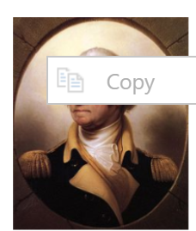
By George 5K and 10K
Saturday, February 14, 2026
5K at 8:00 AM – 10K at 8:10 AM
East Potomac Park, 972 Ohio Drive SW, Washington DC
- Entry Fee: On-line at www.pvtc.org or mail by January 31: $10 (PVTC members) $20 (non-members)
On-line at www.pvtc.org or mail after January 31: $15 (PVTC members) $25 (non-members)
- Join us! Join Potomac Valley Track Club and save $5 on our races – see https://pvtc.org/join
- Race-day: On-site packet pickup is open 7:00 AM-7:45 AM. No race-day registration
- Awards: Cherry pies for top 3 in 10-year age groups M/F plus racewalkers
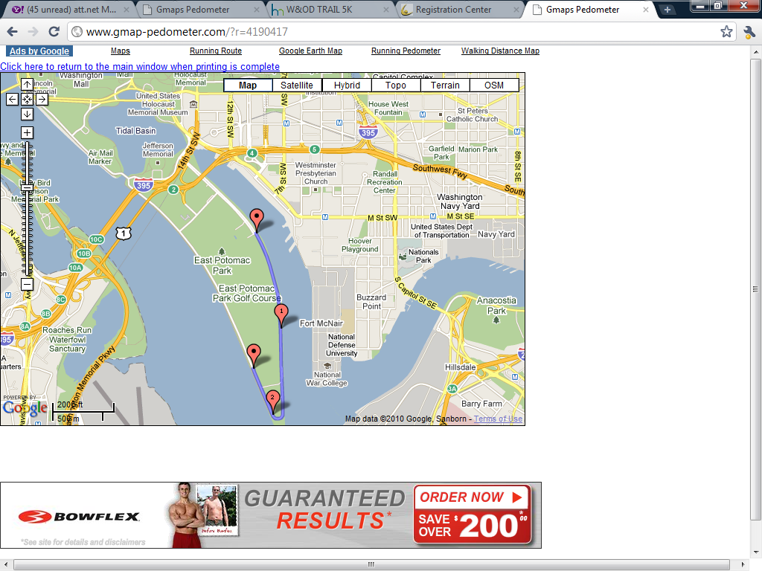
- Course: Flat – walker- and wheelchair-friendly

HYPERLINK "https://certifiedroadraces.com/certificate/?type=l&id=DC11002RT"USATF Certified Course DC11002RT

One or two out’n’back segments on paved roads
- Parking: Ample and free at East Potomac Park Golf Course
972 Ohio Drive SW, Washington DC
- Race size: About 100 in each race, 5K and 10K.
Must finish by 9:30 AM. Only one race per person
- Starts: 5K run & race walk at 8:00 AM,
10K run at 8:10 AM
10K starts about 200 feet north of the 5K start
- Post-race: Refreshments to keep you warm & cherry pies
- Contact: Mike Cannon
pvtcracedirector@gmail.com – 910-261-8446
- Enter all five 2025 races for the price of four – $40 for PVTC members, $60 for non-members
- Enter on-line: https://www.active.com/washington-dc/running/distance-running-races/pvtc-by-george-5k-and-10k-or-all-5-races-2025

PVTC ENTRY FORM
By George bib number

___ ___ ___ ___

Send form and check to
PVTC, 611 South Ivy Street, Arlington VA 22204
or bring this form with you on race day


Name ________________________________________ Age on race day __ __ M/F __

Address ________________________________________ Birthdate ____ ____, _______

City, State, ZIP ________________________________________ Phone _____________________________

E-mail ____________________________________________________________________________

Event [__] 5K run [__] 5K race walk [__] 10K run [__] Wheelchair
Enclosed is [__] $10 (PVTC members) [__] $15 (non-members) by January 31
Late entry [__] $20 (PVTC members) [__] $25 (non-members) after January 31
All 5 races [__] $40 (PVTC members) [__] $60 (non-members) by January 31
[__] Here is an additional $20 for PVTC membership No race-day registration
[__] Here is an additional donation of $ ______ . Total enclosed: $ ______
[__] I will help as a volunteer. Please call me. [__] Send me a membership form
I know running a race is a potentially hazardous activity. I should not enter and run unless I am medically able and properly trained. I agree to abide by any decision of a race official relevant to my ability to safely complete this event. I assume all risks associated with running in this event, including, but not limited to: CONTRACTION OF ILLNESS INCLUDING COVID-19, falls, contact with other participants, effects of the weather, including high heat and/or humidity, and conditions of the course, all such risks being known and appreciated by me. Having read this waiver and knowing these facts, and in consideration of your accepting my entry, I, for myself and anyone entitled to act on my behalf, waive and release all sponsors, including Arlington County Virginia, District of Columbia, its elected and appointed officials and employees, National Park Service, Potomac Valley Track Club, RRCA, and USATF, their officers, directors, agents, and employees, and all officials of this event from all claims or liabilities of any kind arising out of my participation in this event even though that liability may arise out of negligence or carelessness on the part of the persons named in this waiver. I understand this event is conducted under the regulations of National Park Service. I agree to release my name and photo for publicity purposes. I agree that my name and address may be provided to the sponsors of this event. I agree that my entry fee is non-fundable. Parent or guardian must sign for children under 18.

Signature (Parent or Guardian if under 18) _____________________________________ Date _____________

